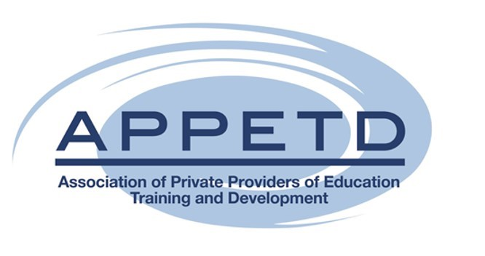

On behalf of the Council of Higher Education an invitation to attend and participate in the Higher Education Practice Standards Capacity Building Workshop

REGISTRATION FORM

Private Provider Institution Name:
Delegate Name:
Designation:
E-mail address:
Telephone number:
Select Province: | Johannesburg  20 April 2023 |  | Cape Town  11 May 2023

Please ensure the registration form is submitted to events@appetd.org.za.

